CST3990
UNDERGRADUATE PROJECT
FINAL REPORT
CLOUD KITCHEN WEBSITE

Autumn/Winter term
2025/2026

Date: 24-April-2026
Supervisor: Dr. Sumitra Kotipalli
Student Name: Sai Neeti Siva Kumar Sayam
Student ID Number: M00979693
Campus: Middlesex University Dubai
Title: Cloud Kitchen

Department of Computer Engineering and Informatics

Student Name: Sai Neeti Siva Kumar Sayam
Student Id No: M00979693
Module number: CST3990

I hereby confirm that the work presented here in this report and in all other associated material is wholly my own work. I confirm that the report shall be submitted to TURNITIN on the understated date.

Signature:
Date: 24-April-2026

Abstract

The concept of Cloud Kitchens, which started as a necessity during the COVID pandemic to avoid physical contact and to cut travel time in reaching a restaurant, has now become a thriving business model. Several Cloud Kitchens have mushroomed both in the UAE and elsewhere. However, most cloud kitchens don’t have a direct relation between the in-stock inventory and the orders being made. This results in significant losses for Cloud Kitchens as they cannot accept orders when they are out of stock. The application developed here attempts to bridge that gap. Another area of concern with cloud kitchens is the health of customers, as they tend to order without much idea of the nutrition value of the meal being ordered. This cloud kitchen website displays the nutrition value of the dishes being ordered, so that customers are conscious of the impact of the food being ordered on their health.
The web-based application has two portals – one for customers and another one for the cloud kitchen staff or admins. The backend web service and database are hosted online so that they are easily accessible.
The report is divided into ten sections. The introduction section talks about the need and scope of this application, where the background section talks about the existing applications related to cloud kitchens. The requirements gathering section looks at the need of the users and displays list of functional and non-functional requirements, which then allow the requirements analysis to be carried out for the application. The planning phase consists of the macro schedule and Gantt chart. The design phase consists of ER diagrams, class diagrams and Use-Case diagrams that help to design and implement the solution. The Design phase also describes the technology used in developing this application. Implementation stage describes the development phase. The testing section details the test cases for testing the completed system. The demonstration section consists of screenshots of every screen to show how the application works. In the end, the conclusion section outlines the future enhancements made to this website to make it commercially usable. The report is concluded with an appendix that lists the references.

Introduction
Since its evolution, mankind has faced many challenges, some of which threatened our very existence. Some challenges were natural, while few others were man-made. One such disaster in recent times has been the COVID-19 pandemic, which threatened the very existence of mankind. It is a lethal form of coronavirus that rapidly spread across the world, taking few million lives during 2019-2021.
While the pandemic posed several challenges like health hazards, economic disruption, social and psychological impact due to multiple lockdowns, etc., technology came to the rescue to fight the pandemic on multiple fronts. Multiple vaccines were invented in record time, reducing the impact of the pandemic on the health of affected human beings.
Several industries were hit badly due to lockdowns. This led to job losses in thousands. Demand for physical stores and shopping went down by more than 90%, as customers were reluctant to go out and shop due to the fear of getting infected by the virus. The food and beverage industry was no different. During the pandemic, several hotels and restaurants were shut down due to lack of business. Once again, technology came to the rescue in the form of e-Commerce websites and online shopping.

Background
Though online shopping was already available through e-Commerce websites, they were always considered as an electronic substitute for physical shopping but not the primary mode of sale. Due to the lockdown, the demand for e-Commerce grew leaps and bounds. As smartphones were widely available, e-Commerce was not only done through websites but also through mobile apps. Simultaneously, businesses started realising that e-Commerce required much lesser physical space and manpower. Large offices and showrooms were replaced by smart warehouses which could easily cater to the high online demand. One of the offsprings of the online culture was the concept of Cloud Kitchen.
Instead of individual food outlets maintaining physical dining space, expensive interiors and serving manpower, a cloud kitchen (especially referred to as a ghost kitchen or dark kitchen) is a food business designed for preparing meals only for delivery or takeaway, with no physical dine-in space for customers. In simple words, a cloud kitchen is a restaurant that operates only through online food delivery apps and websites.
As per Marmore MENA, the key differences between a traditional restaurant and a cloud kitchen are listed in the table below:
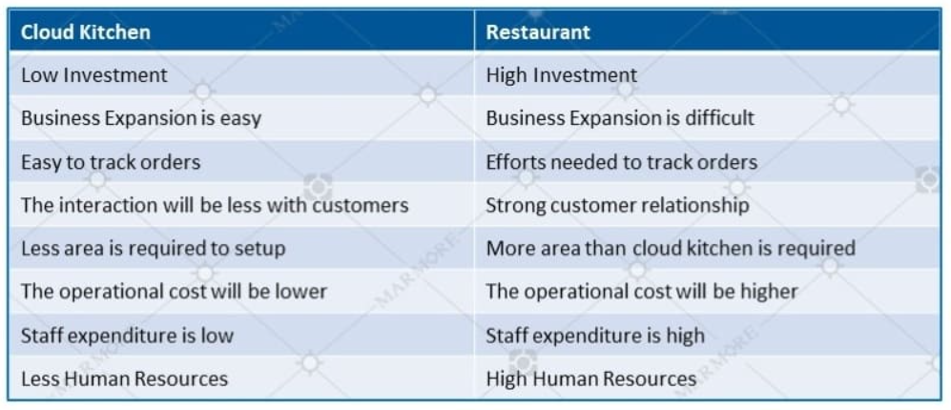
Table 1.1
As quoted by Marmore MENA, “with the increased penetration of dark kitchens following the COVID pandemic, the UAE online food delivery market is predicted to develop at a CAGR of 23%, based on the research from business consulting company RedSeer, with over 400 brands and more than 80 locations in the UAE, the number of dark kitchen brands and outlets has expanded as well.”
Reference: Emergence of Cloud Kitchen https://www.marmoremena.com/en/insights/emergence-of-cloud-kitchens-in-the-uae/

Concept of Cloud Kitchen
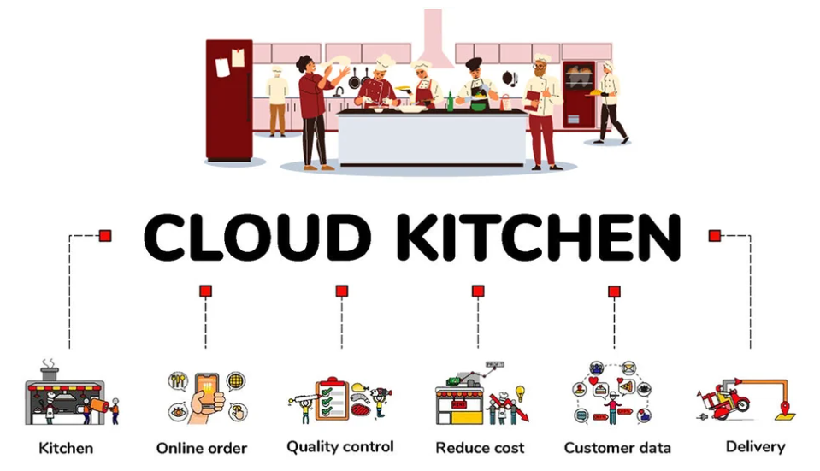
Source: foodsbiz.com
Fig 1.2

Key Points on Cloud Kitchens:
How does a cloud kitchen work?
- Customers place orders through apps like Uber Eats, Talabat, or Zomato.
- The kitchen prepares the food.
- The order is delivered to the customer.
- There is no dining area for customers.

Key Features:
- No dine-in service
- Lower operating costs (no waiters, less rent)
- Operates mainly through online platforms
- Can run multiple food brands from one kitchen
Advantages:
- Lower investment compared to traditional restaurants
- Faster business setup
- Flexible menu changes
- Easy to target online customers
To put altogether, a cloud kitchen is a delivery-only restaurant whose business mainly depends on food delivery apps/websites instead of having a physical dining space.

Requirements Gathering
Cloud kitchen management software plays a vital role in handling online orders, managing inventory, tracking deliveries, and analysing customer preferences. However, despite its growing adoption in the food service industry, existing cloud kitchen software systems still face several limitations that hinder operational efficiency and business growth.

As per Barometer, inventory challenges for cloud kitchens can be surprisingly complex and costly. Without a proper strategy, these challenges can quickly eat into margins and hurt operational efficiency.
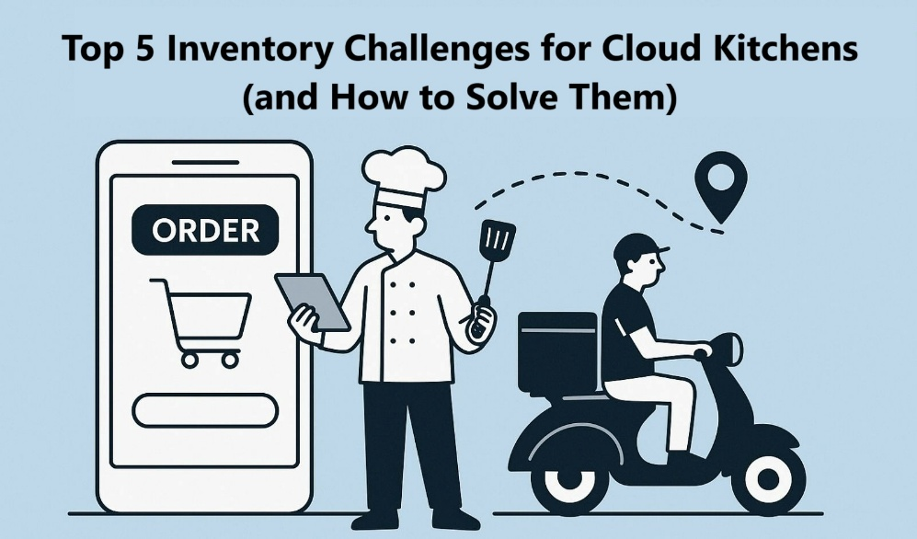
Source: www.barometertech.com
Fig 2

Challenge #1: Lack of Real-Time Visibility
Problem: Unlike traditional restaurants, where chefs and managers can see shelves and fridges physically, cloud kitchens often operate from multiple dark kitchen units or shared spaces. Teams may rely on outdated Excel sheets or manual counts, leading to blind spots. This can cause over-ordering, understocking, or wastage of perishable goods.
Solution: Invest in an inventory management software designed specifically for the F&B industry. Real-time dashboards give your team an accurate view of stock levels anytime, anywhere. Real-time data also means you can respond quickly to unexpected spikes in demand like sudden festival orders without panic purchasing.
Challenge #2: High Food Waste and Spoilage
Problem: Food waste is a universal issue, but it becomes more pressing in cloud kitchens that run lean menus across multiple brands. Spoilage often happens when inventory isn’t rotated properly (FIFO – first in, first out), when chefs overproduce, or when demand forecasting is inaccurate.
Solution: Combine smart forecasting with process discipline:
- Use your POS and sales data to track demand trends by weekday, holiday, and season.
- Integrate inventory software with sales to predict usage and auto-generate purchase orders.
- Train staff to follow FIFO and maintain clear storage labelling.
This dual approach of technology + process can significantly reduce spoilage and keep your kitchen cost-efficient.
Challenge #3: Recipe-Level Cost Control
Problem: Many cloud kitchens struggle to track the true cost of each dish. It’s easy to list a selling price, but knowing the exact cost of every ingredient (including garnishes, oils, or sauces) is tricky. This leads to hidden cost leakages and erodes profits.
Solution: Implement recipe management tools within your inventory software. With recipe costing, every dish has a cost card, showing each ingredient’s quantity and cost. You’ll see not only the total cost but also your gross profit margin per dish.
This empowers chefs and owners to make data-driven decisions, like removing low-margin dishes or reengineering recipes to reduce cost without compromising quality.
Challenge #4: Manual Processes and Human Error
Problem: Many cloud kitchens still track stock using spreadsheets, paper, or WhatsApp updates. Manual entries lead to data duplication, forgotten adjustments, or calculation mistakes. These errors accumulate over time, making end-of-month stock reconciliations painful and inaccurate.
Solution: Automate your inventory workflow:
- Use digital systems for goods receiving, stock transfer, and daily consumption.
- Introduce barcode or QR scanning to speed up and standardise data entry.
- Set alerts for discrepancies or unusual variances.
Automation not only saves hours every week but also provides accurate data for monthly audits and profit and loss analysis.
Challenge #5: Managing Multiple Brands Under One Roof
Problem: Cloud kitchens often run several brands from the same kitchen. The same stock (e.g., chicken, spices, sauces) is shared across brands. Without proper tracking, it’s hard to allocate costs fairly, track consumption per brand, or measure which brand is profitable.
Solution: Use multi-brand inventory management that supports cost centre allocation. Track inventory usage by brand, kitchen, or outlet. At the end of the month, generate brand-wise cost reports and profitability analysis.
With such insights, you can spot underperforming brands, adjust pricing, or redesign menus to boost margins.

Aims and Objectives of this Project
Among the list of problems stated in the previous section, in this project, we attempt to address majority of the concerns by implementing a Smart Inventory Management System.
Most cloud systems have these perennial problems because their customer relationship management software (CRM) is not integrated with their inventory control.
Inventory is the stock/volume of raw materials needed to prepare a finished product. In the context of cloud kitchens, the CRM databases which track customer orders are disjoint from the inventory of raw materials consumed to prepare the dish ordered through the CRM system. This results in the following problems:
- The CRM software doesn’t auto-deduct ingredients
- The CRM software doesn’t predict stock requirements
- The CRM software doesn’t warn about wastage or expiry

The following improvements are made in this cloud kitchen system where customer orders and inventory control of raw materials are directly related.
- Auto stock deduction per order
- Report of inventory available in the Cloud Kitchen
- Supplier integration for auto reordering

Taking the duration in which the project needs to be completed, couple of points from the above list shall be targeted and implemented so that the customer ordering system and the inventory control of stock (raw material) are tightly integrated within our application.

Functional Requirements
Therefore, the functional requirements of our cloud kitchen application are listed in the following table.
Requirement No. | Detail
#1 | A registration cum login page for customers to create their accounts and login to the website.
#2 | A facility to login securely into the Admin Portal of the cloud kitchen for staff.
#3 | A facility to add new dishes to the cloud kitchen menu.
#4 | With each dish, the stock available within the kitchen is stored and updated with each order.
#5 | The nutrition facts and price of each dish is stored in the database. This allows the website to notify customers with nutrition facts of each dish while they order the food.
#6 | Store the category of a dish and tag them with keywords to attract customers.
#7 | A facility to add new stock per dish to the inventory of the cloud kitchen.
#8 | A facility to delete a dish from the menu of the cloud kitchen.
#9 | A facility to update the price and available stock for a dish (to be used when new stock arrives).
#10 | A facility to display all dishes in the menu including the stock available in the kitchen.
#11 | When an order is placed by a customer, the system automatically deducts the quantities of stock per dish that is ordered.
#12 | When the stock is low for a dish, customer is flagged to hurry with the order before the cloud kitchen runs out of stock for that dish.
#13 | When no stock is available for a dish, prevent the customer from choosing that dish for adding it to the cart.
#14 | Facility for the customer to update their address as needed.
#15 | In the Checkout page, display the dishes selected along with their price, quantity and amount (price x quantity).
#16 | Calculate and display the bill total to the customer prior to Checkout.
Table 2.2

Non-functional Requirements
There are a few non-functional requirements to be documented which are listed below.
Requirement No. | Detail
#1 | The customer portal shall be made publicly available.
#2 | The Admin portal shall have restricted access.
#3 | The website shall function efficiently with no time delays to display the page.
#4 | The database shall be accessible online to the web service.
#5 | The web service shall be hosted such that it is available on demand.
#6 | The source code for both the frontend and backend shall be maintained in a Source Control system.
Table 2.3

Requirements Analysis
Based on the requirements listed in the previous section, a high-level Use Case diagram has been developed for clarity of understanding.
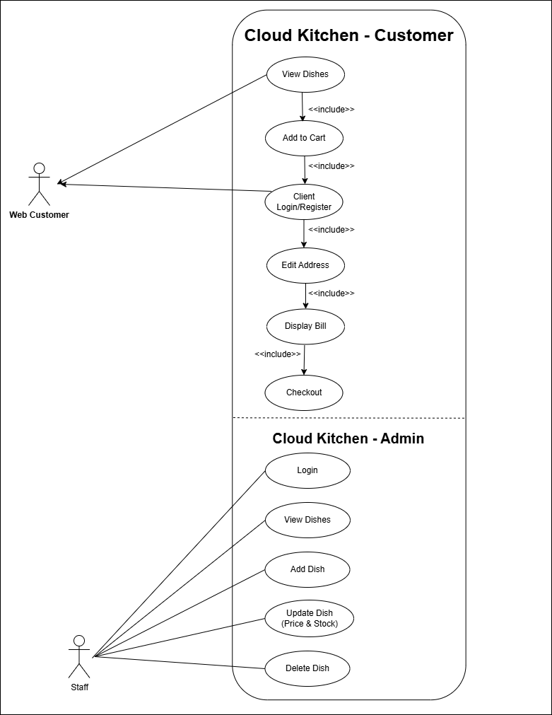
Fig 3.

Use Case Narrative
The Use Case diagram is split into 2 parts.
- Customer Portal
- Staff Portal
The Customer portal displays the menu items along with the price and nutrition facts. Customers can add individual dishes to the shopping cart. The shopping cart displays the number of dishes selected. When the customer has made the selection and is ready to check out, the “Shopping Cart” button is clicked which displays the next screen.
The customer is now prompted to login using their mobile number. The system checks if the mobile number entered is available in the database. It then prompts the user to enter the password. If the account is not found, the customer is appropriately notified and prompted to enter a new password and register.
The customer can enter/edit their address, view the order details and the total amount before final checkout.
On the other hand, the Staff portal verifies the password entered and provides four options – display dishes, add dish, update dish and delete dish.

Analysis
The following table analyses each functional requirement into a software requirement in order to facilitate the design and development effort, testing, deployment, rollout and documentation.
No. | Customer Requirements | Requirement Analysis
#1 | A registration cum login page for customers to create their accounts and login to the website. | - The frontend of the customer portal must allow a new customer to register using their mobile number. A new customer should be able to specify a password for their account. The new customer should be able to enter their full name, address, and nearest landmark which would help in locating the customer easily for easy delivery. The account details must be created in the database.  - The frontend must also allow an existing customer to login in using their mobile number. An existing customer should be able to login by entering their password. The system shall retrieve the customer account from the database and allow the user to edit the name, address and landmark if needed.
#2 | A facility to login securely into the Admin Portal of the cloud kitchen for staff. | - The frontend of the Admin portal shall allow logging in with a password. This portal shall only be used by the Cloud Kitchen staff.
#3 | A facility to add new dishes to the cloud kitchen menu. | - The cloud kitchen staff shall be able to add a new dish to the menu. The details for each dish are the name, price, category, available stock, nutrition facts, URL to an image and tags or keywords for the dish.  - The system shall automatically assign the next available dish Id to the new dish being added.
#4 | With each dish, the stock available within the kitchen is stored and updated with each order. | - In the modern day kitchens, the raw material required to prepare a dish are stored as separate units. By doing so, it becomes easy to have control over the stock for each dish and take corrective action as soon as the kitchen is running low with the stock of a particular dish.  - The cloud kitchen staff shall be able to update the available stock whenever they receive additional stock for a dish from their supplier.  - Whenever a customer places an order, the stock of the items within the order shall be automatically updated based on the number of items ordered.
#5 | The nutrition facts and price of each dish is stored in the database. This allows the website to notify customers with nutrition facts of each dish while they order the food. | - In the customer portal, the customer shall be able to view the price of each dish being ordered, as well as the nutrition facts of the dish.  - The frontend shall allow variable number of nutrition facts per dish.
#6 | Store the category of a dish and tag them with keywords to attract customers. | - The category of each dish like “starter”, “main course”, “soup”, “dessert”, etc. is stored with each dish.
#7 | A facility to add new stock per dish to the inventory of the cloud kitchen. | - Admin staff shall be able to update the stock available for each dish.
#8 | A facility to delete a dish from the menu of the cloud kitchen. | - There may be few instances when a dish needs to be removed from the menu. The system shall allow the Admin staff to delete a dish from the menu.
#9 | A facility to update the price and available stock for a dish (to be used when new stock arrives). | - Admin staff shall be able to update the price of a dish from time to time.
#10 | A facility to display all dishes in the menu including the stock available in the kitchen. | - The Admin portal shall display all dishes in cloud kitchen along with their respective stock available within their kitchen.
#11 | When an order is placed by a customer, the system automatically deducts the quantities of stock per dish that is ordered. | - The customer portal is tightly integrated with the inventory. As soon as an order is placed, the system shall deduct the item count for each dish in the cart from the available stock.
#12 | When the stock is low for a dish, customer is flagged to hurry with the order before the cloud kitchen runs out of stock for that dish. | - When the stock of a dish is less than five, the system shall urge the customer to place their order as soon as possible, lest they face the risk of no stock being available.
#13 | When no stock is available for a dish, prevent the customer from choosing that dish for adding it to the cart. | - When the stock available for a dish reaches zero, the system shall not allow customers to make a selection and add that dish to the cart.
#14 | Facility for the customer to update their address as needed. | - During Checkout, customers shall be able to update their address if needed. The new address is updated in the database against the customer record.
#15 | In the Checkout page, display the dishes selected along with their price, quantity and amount (price x quantity). | - The system shall display the items selected along with the price, quantity and amount to pay for each dish.
#16 | Calculate and display the bill total to the customer prior to Checkout. | - The system shall display the total amount to be paid for the order.
Table 3.2
The above table analyses each requirement in detail. This helps to plan the system design and accurately estimate the effort involved in implementing it.

Project Plan and Schedule
Detailed requirement analysis paves the way for preparing a micro-level project schedule. The schedule sequences the correct order of design and implementation such that, dependent tasks are linked to be implemented in the correct order.
GANTT-CHART: Project Plan and Deliverables
ID | TASKS | Start date | End date | DURATION  (Days) | COMMENTS ON DELIVERABLES
1 | Develop Use Case Diagrams for Staff and Customers | 18-Mar-26 | 20-Mar-26 | 3 | To be drafted using draw.io and included in the final report.
2 | Develop ER diagrams for the database and create collections in MongoDB. | 25-Mar-26 | 27-Mar-26 | 3 | To be drafted using draw.io and included in the final report.
3 | Develop middleware (web service) for staff and customers. | 01-Apr-26 | 3-Apr-26 | 3 | The web service shall be tested using Postman. The web service shall be posted on GitHub and executed using Render.com
4 | Develop Frontend for the Staff (for editing the available stock and the price of a dish). ingredients (stock)). | 08-Apr-26 | 12-Apr-26 | 5 | The frontend for staff shall be posted on GitHub and made public.
5 | Develop Frontend for Customers (for registration and placing orders). | 15-Apr-26 | 19-Apr-26 | 5 | The frontend for customers shall be posted on GitHub and made public.
6 | Compile the documentation for the final report. | 20-Apr-26 | 24-Apr-26 | 5 | Get the completed report reviewed by my supervisor.
Table 4.

Gantt Chart
Based on the above schedule, the following Gantt Chart shows the software tasks to be designed, developed and tested. The schedule also takes into account the preparation for other modules/lessons to be learnt simultaneously.
A usage guide shall also be added to the Appendix of the final report.
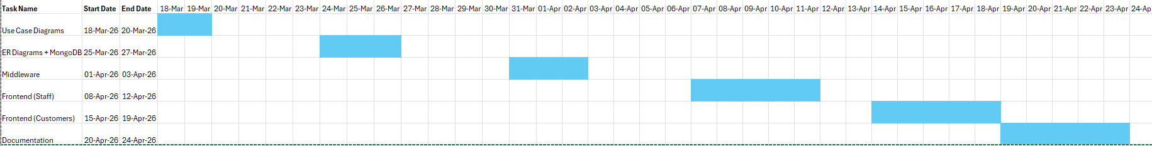
Fig 4.1

System Analysis and Design
Since this is a software development project, this section covers the requirements, design, planning and implementation highlights of the project.
- Functional Requirements for development of a website for hosting a cloud kitchen. There shall be two types of users for the cloud kitchen namely STAFF and CUSTOMERS.
- Staff are the staff members of the cloud kitchen who can access the admin menu of the website.
- Customers are the people who register and want to order food from the cloud kitchen.
The detailed functional requirements are listed below.
  - Develop a UI for staff registration using their email address, name and password. All details entered shall be stored in a database collection (table), named “STAFF”.
  - Develop a UI to add new dishes to the menu. This shall be available only when a staff logs in to the system. The details for each dish shall include name of the dish, a picture, ingredients with quantities, nutrition facts, cost price and selling price. All details entered shall be stored in a database collection (table), named “DISHES”.
  - Develop a UI to add new stock to the inventory. This shall be available only when a staff logs in to the system. For each ingredient, record the quantity being added to the inventory. The ingredients and their quantities need to be stored in a separate collection called “INGREDIENTS”.
  - Develop a UI for customer registration using their email address, name, password, address and mobile number. All details entered shall be stored in a database collection (table), named “CUSTOMERS”.
  - Develop a UI for customers to place orders. In each order, multiple dishes and quantities can be selected. Upon selection of a dish, the nutrition facts for the dish shall be displayed in the UI for customer’s information.
  - The selected dishes shall be added to the cart.
  - Develop a UI for Checkout. The ingredients consumed by each dish ordered shall be reduced from the respective ingredients collection. The order details are posted in the “ORDERS” collection along with customer’s name.

- Non-functional Requirements
  - The staff UI is local to the cloud kitchen and need not be available to public.
  - The customer UI needs to be publicly available through a secure HTTPS connection.
  - When the minimum level is reached for an ingredient, the system throws a message to the staff.

- Functional Design
The functional design of the application shall be documented in the final report. The functional design shall be represented through the following media.
  - Use Case Diagrams shall be drafted and included in the final report, depicting how staff and customers interact with the application.
  - Entity-Relationship (ER) diagrams shall be developed and included in the final report which will have all the collections, their fields and relationships to other collections.

- Hardware Requirements
The project shall be coded using the personal laptop of the student. No other hardware requirements are envisaged for implementing this project.

- Software Requirements
  - Frontend: This application shall have two user interfaces (UI), the first one being for the cloud kitchen staff and the second UI being the customers’ portal. The front-end for both interfaces shall be developed in HTML and the code behind in Vue.js.
  - Middleware: A server application shall be developed to handle editing of records for STAFF, CUSTOMERS, DISHES, INGREDIENTS and ORDERS. This application shall be developed in Express.js and Node.js. It will be hosted as a web service that caters to client requests from the frontend.
  - Backend: The database shall be hosted in MongoDB. Separate collections shall be used for STAFF, CUSTOMERS, DISHES, INGREDIENTS and ORDERS.
  - Postman routines shall be used to test editing of records through the web service to the database.
  - The middleware web service shall be hosted on GitHub and executed using Render.com
  - The frontend shall also be hosted on GitHub. Two separate web pages shall be hosted for staff and customers respectively.
Planning and Scheduling

- Appendix – Reference List
  - Emergence of Cloud Kitchen: https://www.marmoremena.com/en/insights/emergence-of-cloud-kitchens-in-the-uae/
  - Technological Challenges of Cloud Kitchens:
https://www.barometertech.com/post/top-5-inventory-challenges-for-cloud-kitchens-and-how-to-solve-them

***********

